Using conda environment in Jupyter Notebook:

The custom conda environment hast to be registered as a kernel in order to be usable by jupyter.

To do this register your environment by opening the Anaconda Powershell Prompt from the taskbar in Windows 10:

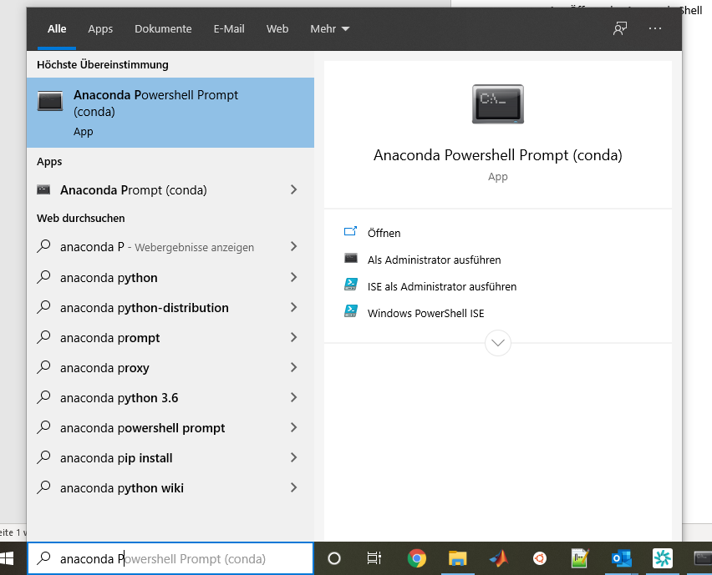

1 Anaconda Powershell Prompt

In the newly opened command prompt type :

python -m ipykernel install --user --name=rio

“rio” being the name of the environment created for this class.

To execute a notebook using the custom environment select it in the kernel Menu:

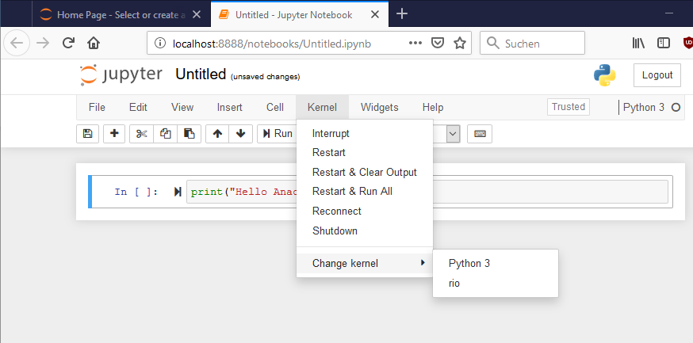

2 Executing code in the correct environment

**You will have to do this in order to run the code provided in the notebooks for this class!**

When creating your own notebooks always make sure you choose the correct kernel:

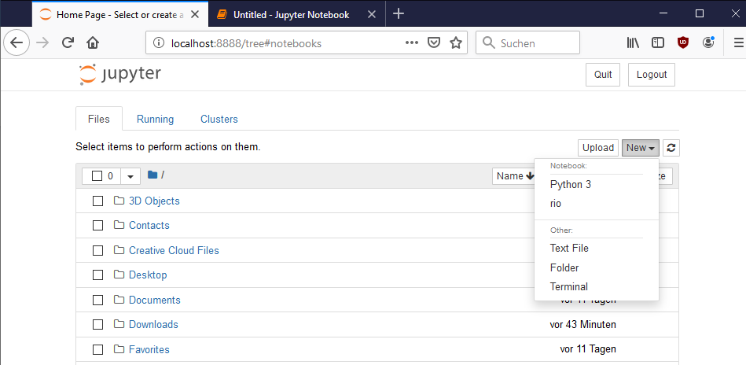

3Create a notebook using the correct environment